**Members :**

Mayank Dhiraj Chopra, 1911006

Pathik Prashant Ghugare , 1911014

**Title : Sign Language Recognition System**

Github Link : <https://github.com/Patrickbro13/Real-Time-Sign-Language-Recognition>

Files Uploaded :

1. Loading_data.py

This file is used to store a dataset in such a way that it will be easier to access and used later . Here, we are storing our data in a list named data .  
Each element in data is also a list where first element is an image and the other is the index of the respective image letter from list

CATEGORIES = [‘A’ ,’B’, ... , ’Z’.]

E.g. [[‘image0 of A’,0], [‘image1 of A’,0], ..., [‘image0 of B’,1],....[‘image200 of B’,1],...]

This data is stored in a pickle file so that we don’t need to load every time and store this whole data folder then each image file again and again.

1. Preprocessing.py

This file is used to preprocess the whole data.

First we shuffled the data using random.shuffle() since the data was in an order the same as A to Z .  
E.g. [[‘image0 of A’,0], [‘image1 of A’,0], ..., [‘image0 of B’,1],....[‘image200 of B’,1],...]

So we took one sample image data[50][0] and checked whether or not everything is working as expected .

After that we applied GaussianBlur() for smoothing of image and cannyEdge detection to detect edges from hand

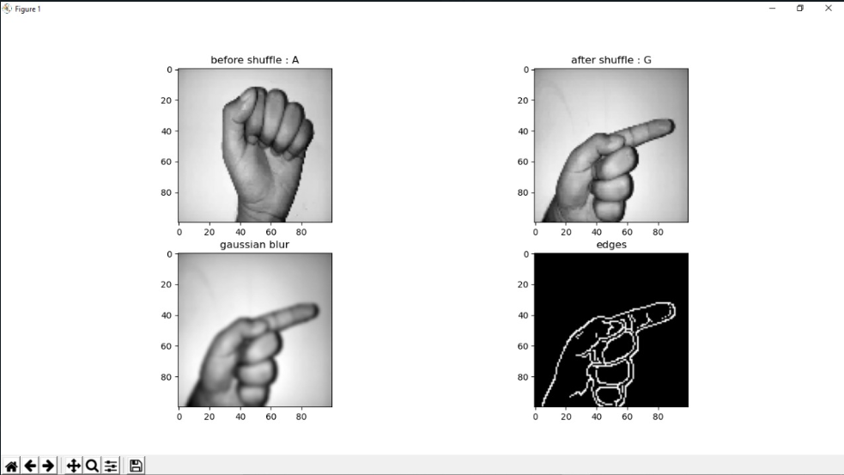

Now the task to be done is to apply this process on all dataset and split it for training and testing of a model.

1. Hand_detection.py

This file is used to detect the hand of a user in real time via webcam.

Here we made a rectangle which is also our ROI ( region of interest) where users will show the sign . On that raw input frame , we applied gaussian blur to smoothen image and then on that smoothen image we applied edge detection algorithm to again detect the edges from his input hands.

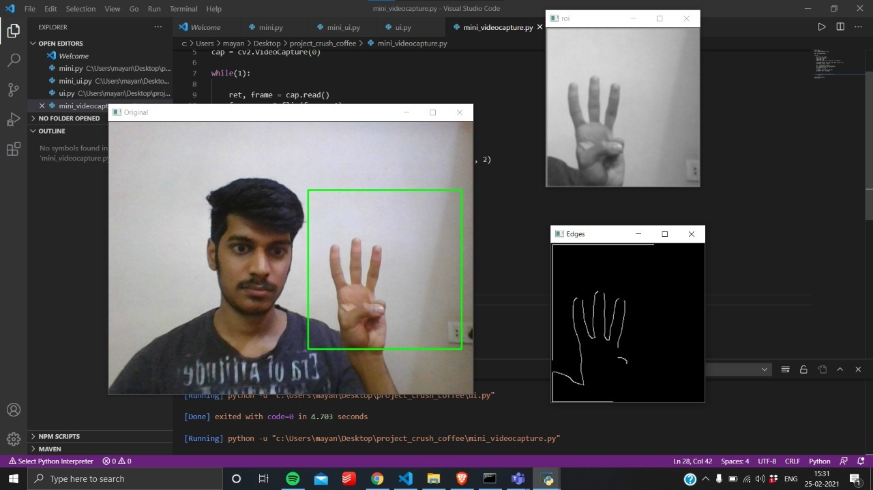

Then we have modified a code a bit by adding contour detection and this are the results :

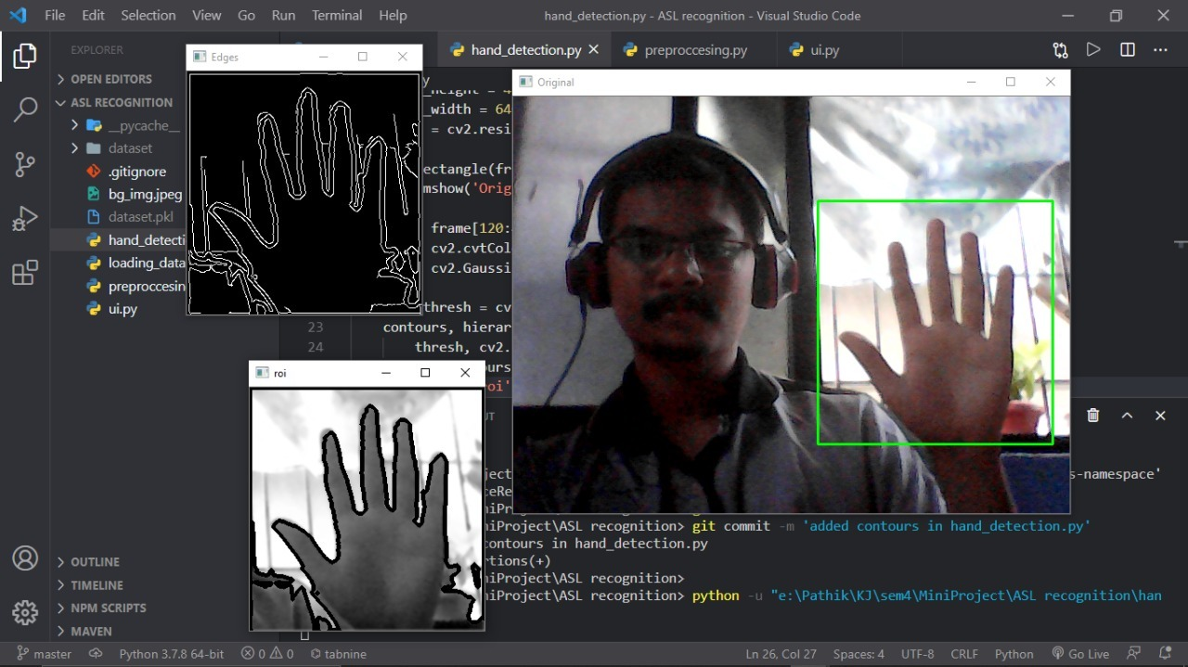

1. Ui.py

With the help of tkinter library home page is created

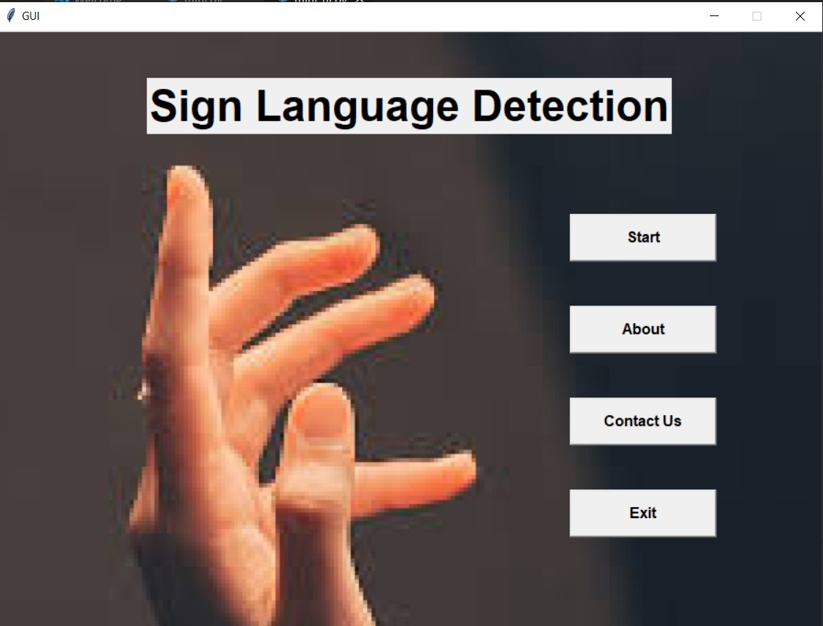

1. ui_aboutus.py

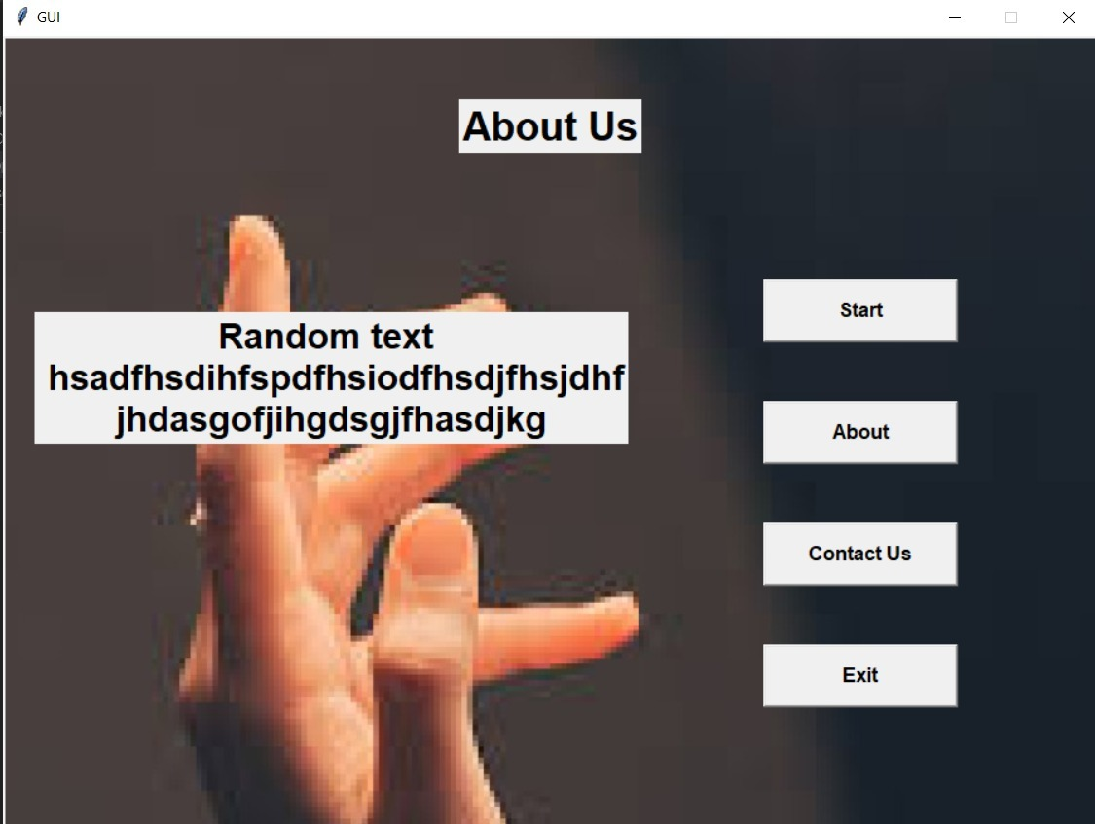

But only the exit button is working for now , navigation to other pages is yet to be done .